**Final Project ECE2310**

**Deliverables:**

1. **UML diagram**
2. **Zipped project folder and a word document of your code and screen shot.**

(20 Points) A community has 7 swimming pools, as shown in the following map.

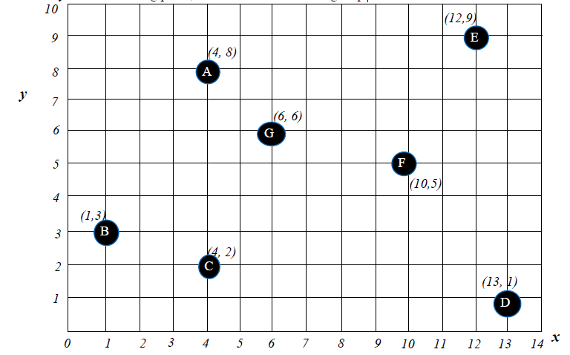

Your project must satisfy the following requirements:

1. Create three classes: **Pool, Temperature**, and **Location**.

2. A swimming ***pool*** shall have an object of “***Temperature***” and an object of “***Location***” as data

members. (“Compositionally” speaking: A ***pool*** has-a temperature, and a ***pool*** has-a location)

3. A *temperature* has “degree” and “scale”.

4. A *location* is defined by (*x, y*); hence a location has an ‘x’ value and a ‘y’ value.

5. Provide ***ToString*** method for all three classes.

6. Provide other member methods for each of the classes properly . For example, a ***FindDistance*** method to find the distance between pools.

7. All methods shall be public.

8. The **Pool** class shall have a ***static*** data member ‘Count’ The driver program shall print out the static member ***count*** before any pool object is created, and also after each pool is instantiated.

9. A maintenance crew can set the temperature for each pool within the range of 98 oF and

104 oF.

Note: generate a **random number** between [*98, 104*].

10. A maintenance person will go through all seven pools and set the temperatures. The person starts from location (0,0), and will go to the ***nearest pool*** after she/he finishes the job. The process continues until all the pools are visited. Each pool can only be visited once.

Your driver program determines and displays the route she/he takes to visit all the pools,

such as :

**(0,0) >> B with temperature at 99 degree F >> C with temperature at 103 degree F >> ... ....**